PIZZA SALES SQL QUERIES
- KPI’S

- Total Revenue
select SUM(total_price) as Total_Revenue from pizza_sales;
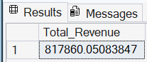
- Average Order Value

select sum(total_price)/count(distinct(order_id)) as Avg_order_value from pizza_sales;
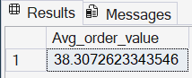
- Total Pizzas Sold
select sum(quantity) as Total_pizzas_sold from pizza_sales;
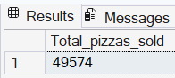
- Total Orders
select count(distinct(order_id)) as Total_orders from pizza_sales;
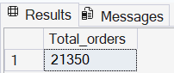
- Average Pizzas per order
select cast(cast(sum(quantity) as decimal(10,2))/cast(count(distinct(order_id)) as decimal(10,2)) as decimal(10,2)) as avg_pizzas_per_order from pizza_sales;
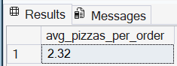

- CHART REQUIREMENTS

- Daily Trends for Total Orders
select datename(dw,order_date) as order_day, count(distinct order_id) as Total_orders
from pizza_sales
GROUP BY datename(dw,order_date);
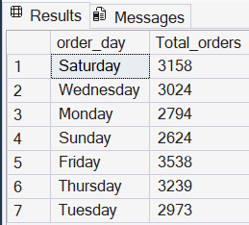

- Monthly trends for total orders
select datename(Month,order_date) as order_month, count(distinct order_id) as Total_orders
from pizza_sales
GROUP BY datename(month,order_date);
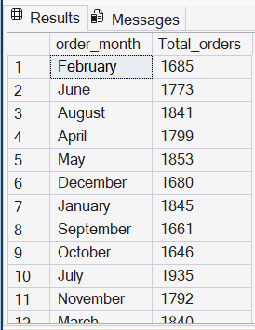

- Percentage of sales by pizza category

select pizza_category, sum(total_price) * 100 /(select sum(total_price) from pizza_sales) as percentage_of_sales
from pizza_sales
group by pizza_category;
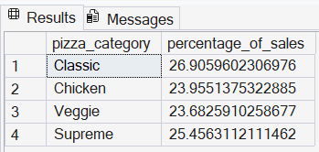

- Percentage of sales by pizza size
select pizza_size,
cast(sum(total_price) * 100 /(select sum(total_price) from pizza_sales) as decimal (10,2)) as percentage_of_sales
from pizza_sales
group by pizza_size;
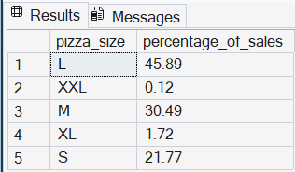

- Total pizzas sold by pizza category
select pizza_category, count(quantity) as total_pizzas_sold
from pizza_sales
group by pizza_category;
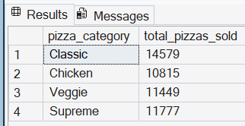
- Top 5 best sellers by Total pizzas sold
By Revenue
select top 5 pizza_name, SUM(total_price) as Revenue
from pizza_sales
group by pizza_name
order by SUM(total_price) desc;
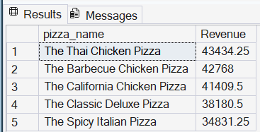

By Quantity
select top 5 pizza_name, SUM(quantity) as Total_qty
from pizza_sales
group by pizza_name
order by SUM(quantity) Desc;
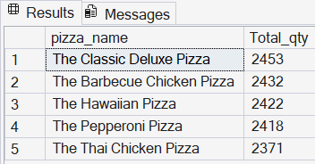

By Orders
select top 5 pizza_name, count(distinct order_id) as Total_orders
from pizza_sales
group by pizza_name
order by count(distinct order_id) desc;
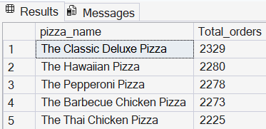

- Bottom 5 worst sellers by Total pizzas sold
By Revenue
select top 5 pizza_name, SUM(total_price) as Revenue
from pizza_sales
group by pizza_name
order by SUM(total_price) Asc;
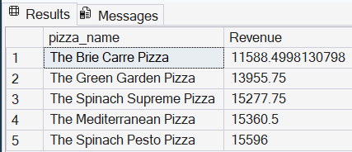

By Quantity
select top 5 pizza_name, SUM(quantity) as Total_qty
from pizza_sales
group by pizza_name
order by SUM(quantity) Asc;
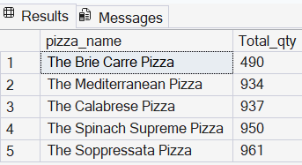

By Orders
select top 5 pizza_name, count(distinct order_id) as Total_orders
from pizza_sales
group by pizza_name
order by count(distinct order_id) asc;
